**Student Performance Dataset:**

## **About Dataset:**

This Dataset consist of 33 Features. This dataset can used for Regression as well as Analysis task.  
This dataset contains some of the unique features like,

* Parents education
* Family relations
* Alcohol consumption
* Marital status of parents
* Family size

**Introduction:**

It is an exploratory data analysis of the Student Performance Dataset. The analysis provides a good starting point for those seeking to predict the final grade a student might receive based on a variety of factors, such as family relationships, free time, parents' education, and absences.

**Exploratory Data Analysis:**

This section concerns the relationship between various features in this dataset. Specifically, this section will focus on the correlation between health-related features and grades as well as the correlation between features regarding familial status and stability and overall grades.

## **Overall Health vs. Grade:**

The relationship between these two features can be depicted using a simple regression plot.

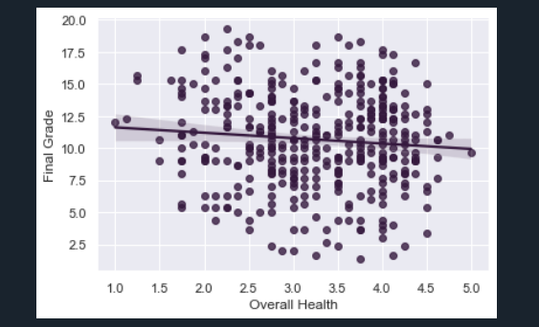

**Observations:**

A better overall health value corresponds to a lower final grade. Conversely, a lower overall health value generally corresponds to a higher final grade.

The slope of the best fit line is a small distance away from zero, so the correlation between Overall Health and Final Grade is low.

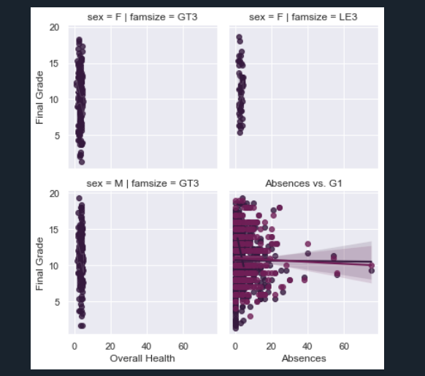

**Observations:**

The family size has a large impact on the slope of the line in the plot; the size of the family can dictate the magnitude to which overall health affects the final grade

## **Absences vs. Grade**

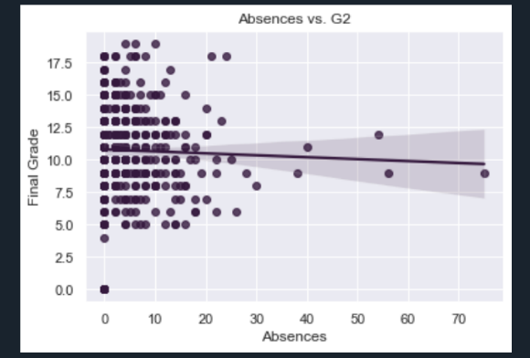

**Family Size vs. Family Relationship**

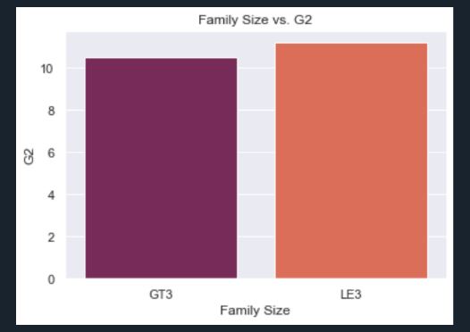

## **Activities vs. Grade**

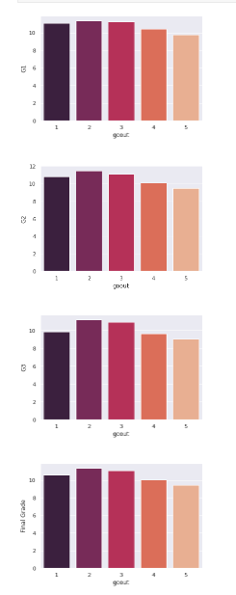

## **Conclusion:**

This section portrayed a surprising relationship between how often a student engages in social activity. Students with social activity, in general, scored better than students without socialization.

On the contrary, students who went out more often tended to score on the lower side of the grade spectrum; the perfect rating in goout was 2, as it resulted in the highest average score for all scoring metrics.

**LINKS:**

Github Link : https://github.com/Maheenkhan22/Assignment.git

Jupyter Notebook Link: http://localhost:8888/notebooks/Assignment_Datasets.ipynb#